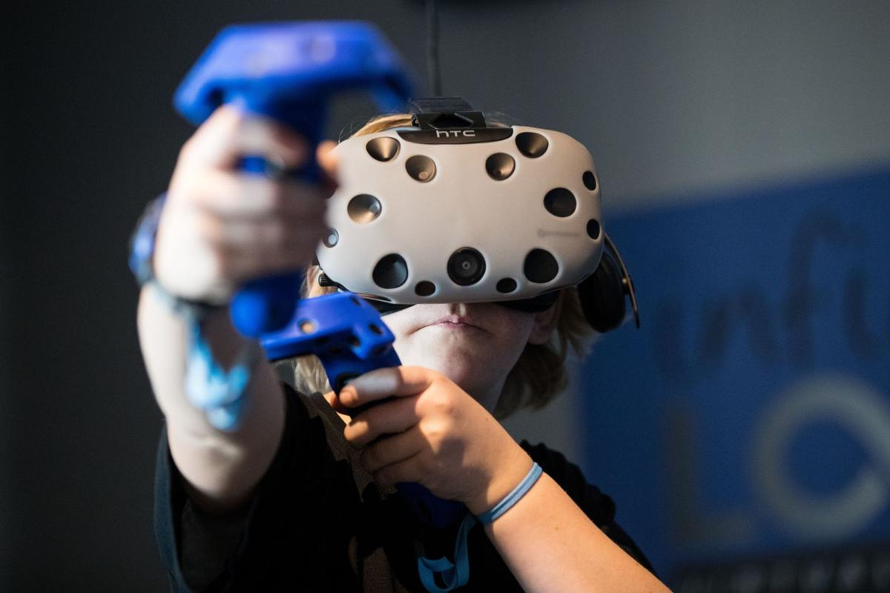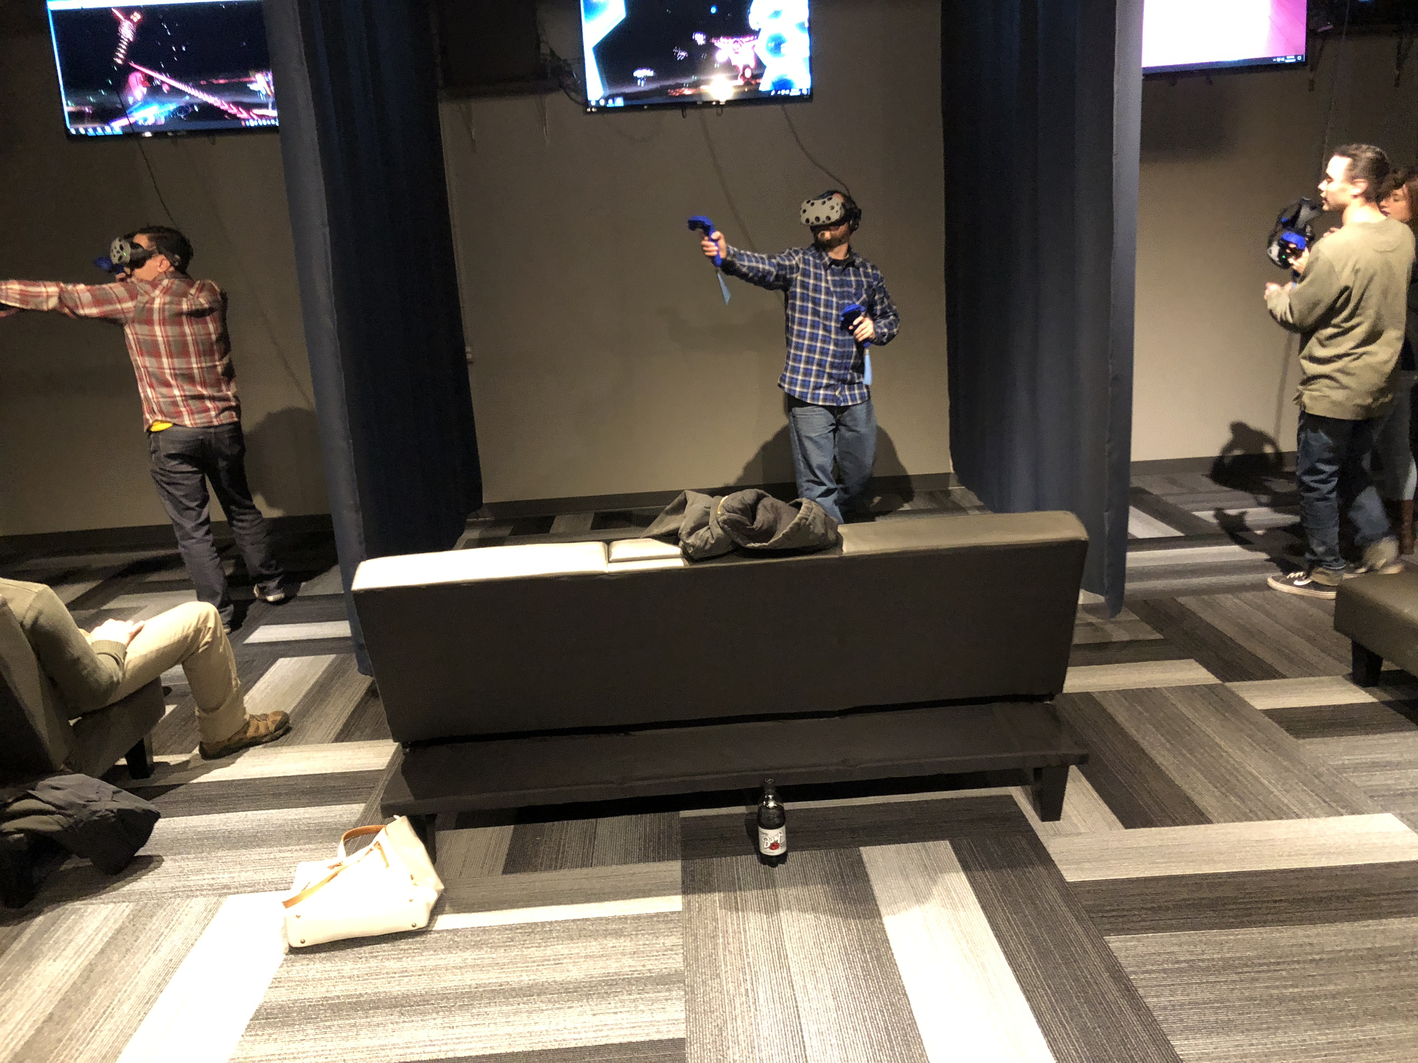

WDate _________________________

Time _________________________

RSVP ________________________

Infinite Loop VR

9825 Giles Rd

La Vista, NE 68128